**Name -** Bodke Sairaj Nivrutti.

**Class –** BE Artificial Intelligence and Data Science.

# Roll No. – 09

**Practical No. 03 -** Write a program for developing an IIoT application for energy monitoring and optimization.

# IIOT Application For Smart Home Energy Monitoring. Circuit Diagram –

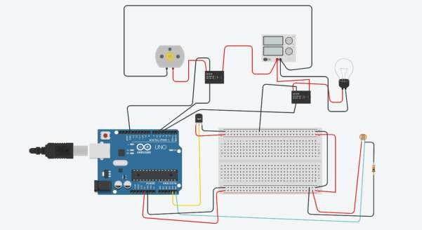

**Source Code –** float x,y,z,temp; void setup()

{

// pinMode(8, INPUT); pinMode(5, OUTPUT); pinMode(6, OUTPUT); pinMode(A5, INPUT); pinMode(A4, INPUT); Serial.begin(9600);

}

void loop()

{

// x= digitalRead(8); y= analogRead(A5); z= analogRead(A4); Serial.println(x); Serial.println(y); Serial.println(z);

temp = (double)z / 1024; temp = temp * 5;

temp = temp - 0.5; temp = temp * 100;

//if ( (x>0) )

//{

if ((y<550)&&(temp>30))

{

digitalWrite(5, HIGH); digitalWrite(6, HIGH);

}

else if((y<550)&&(temp<30))

{

digitalWrite(5, HIGH); digitalWrite(6, LOW);

}

else if((y>550)&&(temp>30))

{

digitalWrite(5, LOW); digitalWrite(6, HIGH);

}

else if((y>550)&&(temp<30))

{

digitalWrite(5, LOW); digitalWrite(6, LOW);

}

/*} else

{

digitalWrite(5, LOW); digitalWrite(6, LOW);

}*/

}

# Output –

53.00

0.00

6.00

153.00